## Merchant: Lawtrades

Demo date: Nov 15, 2024  
Scoping start date: Jun 13, 2024

MSA Signature Date: Nov 26, 2024  
Onboarding Kick Off Date: Dec 4, 2024

[If Exists] Opt Out Date:  
Go Live Date: Mar 1, 2025

GTM POC: Nick  
Implementation POC: ArielDani

ERP: QBO

Tax Integration: QBO Hard Coded Taxes

### 

### Key people at Merchant

### Head of Finance and Operations: Jerry Thomas - <https://www.linkedin.com/in/jerry-thomas/>

* COO: Ashish Walia - https://www.linkedin.com/in/ashishwalia1/
* Billing POC

### Etc.

### 

| Notes Sections [Ops International Team to Ignore] *(AE/ Implementation to fill)*   * Bill for # of hours worked by their Lawyers. Sometimes this is tiered. * Is there any important merchant relationship information? Ashni’s uncle is COO. GS built a great relationship during sales process 1) What is the merchant temperament? * Jerry is a little wishy washy but easy to work with. Genuinely just has a lot on his plate and is hesitant to take on projects 2) Is there a key POC: (i.e.: who is the buyer/decision maker?) * Jerry and Ashish 3) What are the Tabs features that the key POC cares about? * Contract Management, automated invoicing, Rev Rec, and ARR Reporting |
| --- |

### 

### Company summary *(AE to fill)*

Lawtrades is a legal marketplace business doing $12 Million in revenue & profitable. The team is super lean (<12 FTE in the US) & they need to use an invoice factoring service that they pay interest on the longer it takes to collect client bills.

https://www.lawtrades.com/

Goals (North star)  
*(AE/ Implementation to fill)*

What is the merchant's goal? What pain are we solving? Why are they buying Tabs?  
Automating revenue workflows without the need to increase headcount. They have terrible DSO and pay interest on overdue invoices. Currently this is ~60 days and need to get it down to Net 30

Is there an opt out clause? If so, what is the merchant looking for so they do not exercise it?  
No

### Billing model *(AE/ Implementation to fill)*

* Are there unique things about the customer creation process for this merchant?
  + N/A
* Information on how merchant bills
  + # of Hours worked by their team
* How contract is broken up
  + N/A
* One off things to know about the merchant
  + They factor their invoices through OatFi. This is integrated with their existing stack.

### 

### 

### 

### Contract Processing Steps *(Implementation/Success to fill)*

Customer Creation

* If a customer doesn’t exist, please create
* **For existing customers,**
  + For every new contract, double check that the customer billing email and billing address are the same as on the contract
    - If they aren’t, update them in garage

General

1. Find the “Statement of Work” section - generally at the bottom
2. There will be a checked option of one of the following, please go to that section and follow the respective instructions in addition to the General rules in this section

* Normal Hourly Fee
* Discounted Hourly Fee
* Upfront Flat Fee + Hourly Fee

1. Defaults:
   1. Service Start Date
      1. The “Engagement Start Date” in the “Statement of Work” section.
         1. If the Engagement Start Date is 11/18/24, start date is 11/1/24
      2. If no date listed, default to the date the contract was uploaded to garage.
      3. If any contract has a start date in a close period, use the first day in an open period
   2. Billing Start Date:
      1. The 1st of the month for whatever the
         1. If Engagement Start Date is 11/18/24, start date is 11/1/24
   3. Total Months of Service: 12 unless otherwise listed
   4. Frequency: Default to monthly unless the contract specifies that it is billed semi-monthly
   5. Net Terms: 30 unless otherwise listed
   6. **For all USAGE BTs, select “Bill last of period”**
   7. Event types:
      1. The name of the event type is the name of the engaged legal professional
      2. If it does not already exist, you will need to create
   8. Integration item:
      1. The name of the legal professional in the contract (will be the same as the event).
      2. If the integration item does not exist, leave blank and continue processing
         1. Flag to the team so we can let the merchant know.
   9. Complimentary Hours
      1. Need to be billed as a negative discount billing term



* + - 1. Total price will be equal to the hourly rate that has been specified times the number of hours.
      2. The billing and service start dates should be the same as the hourly usage BT
      3. The frequency will be the same as the hourly usage BT
      4. # of periods will be 1
      5. Integration item should be the same as the lawyer name

### **Normal Hourly Fee** [**Garage Example here**](https://garage.tabsplatform.com/prod/contracts/5facd4df-7a86-4d27-af03-d977aaafa05d/preview)

**This is a standard hourly billing contract, with no minimums or thresholds.**

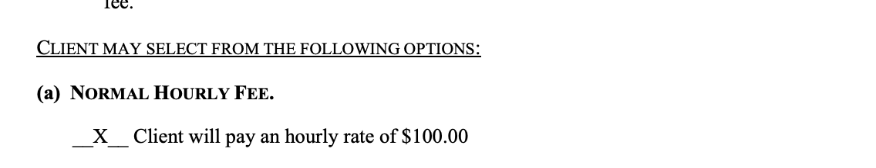

* Item Name: Name the Engaged Legal Professional listed (i.e. “Emmanuelle Berdugo”)
* Integration Item: Name the Engaged Legal Professional listed
* Description: List the hourly rate - format “$100/hr”

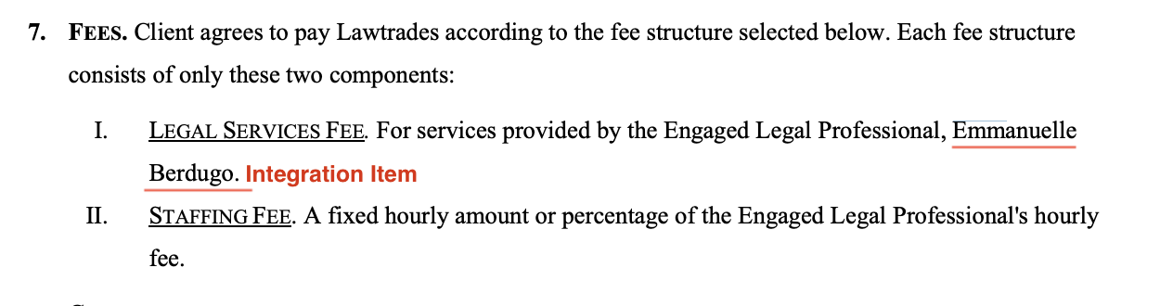

* Billing type: Unit Price
* Total Price: Use hourly rate
* Event to track: Name the Engaged Legal Professional listed
* Service start date: Found in SoW Work Term
* Months of Service: 12 months default
  + If it explicitly states the term length, use that instead
* Billing start Date: Start on the 1st of the month of the start date of the SOW (for monthly or semi-monthly)
* # of Periods:
  + If the Service Start Date isn’t on the 1st of the month:
    - Take the total months of service and +1
      * This is because the BT start dates are backdated slightly
    - So if months of service is 12 and the contract is MONTHLY
      * # of periods should be 13
    - If months of service is 12 and the contract is SEMI-MONTHLY
      * # of periods should be 25 -> 12 * 2 + 1 = 25
* Frequency: Default to monthly if not listed
  + Use semi-monthly if specified
* Net terms: 30 (unless otherwise specified)
* Billing Timing: **Bill Last of Period**

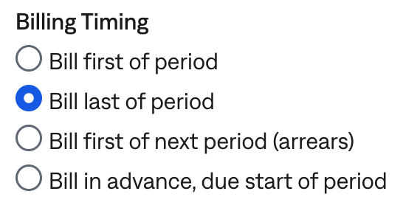

### **Discounted Hourly Fee** [**Garage Example**](https://garage.tabsplatform.com/prod/contracts/619ae84a-1f53-4d90-8785-db214e3f1b5a/terms/key)

**This option usually includes a minimum of a certain amount of hours.**

**Note: the additional “Minimum hours requirement” Flat BTs in the example get generated automatically. Can ignore**

* Item Name: Name the Engaged Legal Professional listed, see example below
* Description: Rate, format “$100/hr”

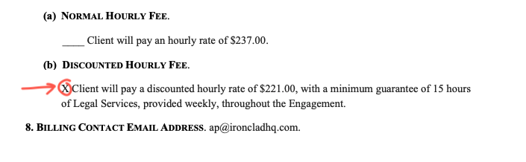

* Integration Item: Name the Engaged Legal Professional listed, see example below

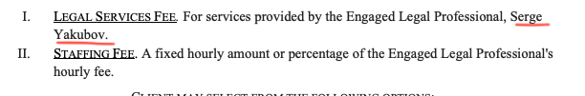

* Billing type: Unit Price
* Total Price: use the discounted hourly rate
  + From example in screenshot above: $221 per hour in the correct rate
  + Do not add any discounts
* Event to track: Name the Engaged Legal Professional listed
* Service start date: Found in SoW Work Term
* Months of Service: 12 months default
  + If it explicitly states the term length, use that instead
* Billing start Date: Start on the 1st of the month of the start date of the SOW (for monthly or semi-monthly)
* # of Periods:
  + If the Service Start Date isn’t on the 1st of the month:
    - Take the total months of service and +1
      * This is because the BT start dates are backdated slightly
    - So if months of service is 12 and the contract is MONTHLY
      * # of periods should be 13
    - If months of service is 12 and the contract is SEMI-MONTHLY
      * # of periods should be 25 -> 12 * 2 + 1 = 25
* Frequency: Default to monthly if not listed
  + Use semi-monthly if specified
* Net terms: 30 (unless otherwise specified)
* Billing Timing: **Bill Last of Period**



**Once the BT is created, go to the Usage AI tab. Configure that form as follows:**

1. Move switch to **Has Minimum**
2. Has use minimum = **Toggle ON**
3. Included products = **Only select the hourly usage BT** (this will be the lawyer’s name)
4. Minimum period = **Individual billing period**
5. True up to meet minimum = **Toggle ON** (default setting)
6. Minimum is fixed = **Toggle ON** (default setting)
7. Adjustment name = **Minimum hours requirement**
8. Integration item = same integration item used in the BT (Name of legal professional)
9. Amount = **hourly rate from the contract * (weekly minimum hours*# of weeks in billing period)**. For the example below:
   1. If semi monthly: 221*(15*2)=6630
   2. If monthly: 221*(15*4)=13260
10. Service period = Check on **Service period same as contract** (default setting)

**BE SURE TO HIT SAVE!**

**Example:**

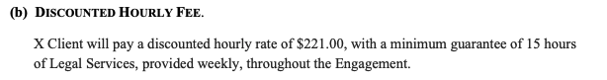

### **Upfront Flat Fee + Hourly Fee** [**Garage Example**](https://garage.tabsplatform.com/prod/contracts/47956622-7b13-47d9-9b02-1174e32b1331/usage)

**Note: the additional “Prepaid Hours” negative Flat BTs in the example above get generated automatically by Usage AI. Can ignore when referencing**

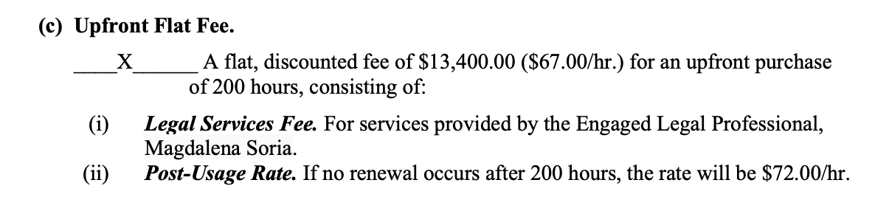

Create THREE BTs

* If the DISCOUNTED rate and the OVERAGE rate are the same rate (or if they don’t mention an overage rate), you only need to create 2 BTs. 1 for the upfront and 1 for the hourly rate
  + You can ignore the extra instructions for item name and event in this case. No need to add “- 1” or “- 2” in this case.
* BT #1 for upfront purchase
  + Item Name: Upfront Fee
  + Description: Rate, format “$67/hr”
  + Integration Item: Name of Engaged Legal Professional
  + Billing type: Flat
  + Total Price: Total price listed, if not available
    - Calculate hours bought x price per hour
      * Example = 100 hours for $180 = $18,000 upfront fee

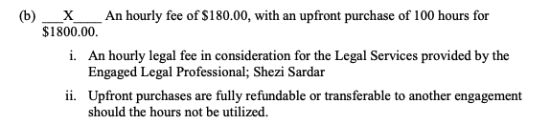

* + - Other times, the total upfront price is listed.
  + Start Date: SOW Term Start
  + Frequency: None
  + Billing Timing: BIll first of period (default)
* BT #2 for DISCOUNTED hourly fee
  + Item Name: Name of Engaged Legal Professional + “- 1”
  + Description: Rate, format “$100/hr”
  + Integration Item: Name of Engaged Legal Professional
  + Billing type: UNIT
  + Event: Engaged Legal Professional Name + “- 1”
    - Example: Magdalena Soria is the lawyer
      * Event should be “Magdalena Soria - 1”
      * Create if not available. Make sure there are spaces between the - and the 1
  + Total Price: the discounted hourly fee
    - This is the rate that they bought the hours for
      * Example: “A flat, discounted fee of $13,400.00 ($67.00/hr.)” -> use $67
      * Example: “Upfront purchase of 100 hours for $180” -> use $180
  + Months of Service: 12 months default
    - If it explicitly states the term length, use that instead
  + Billing start Date: Start on the 1st of the month of the start date of the SOW (for monthly or semi-monthly)
  + # of Periods:
    - If the Service Start Date isn’t on the 1st of the month:
      * Take the total months of service and +1
        + This is because the BT start dates are backdated slightly
      * So if months of service is 12 and the contract is MONTHLY
        + # of periods should be 13
      * If months of service is 12 and the contract is SEMI-MONTHLY
        + # of periods should be 25 -> 12 * 2 + 1 = 25
  + Frequency: Default to monthly if not listed
    - Use semi-monthly if specified
  + Net terms: 30 (unless otherwise specified)
  + Billing Timing: **Bill Last of Period**
* BT #3 for OVERAGE hourly fee
  + Duplicate BT #2 and only change the item name, price, event and description
  + Item name: Name of Engaged Legal Professional + “- 2”
  + Total Price: the overage hourly fee
    - Sometimes, the hourly fee is listed in a **POST-USAGE RATE** section
      * This is because the hourly fee for overages is different than the hourly fee used to calculate the up-front amount.
      * **Use this rate**
      * Example below: Post usage rate = $191

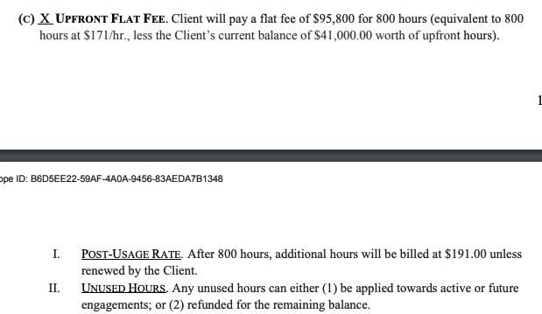



* Event: Engaged Legal Professional Name + “- 2”
  + Example: Magdalena Soria is the lawyer
    - Event should be “Magdalena Soria - 2”
    - Create if not available. Make sure there are spaces between the - and the 2
* Description: overage rate, format “72/hr”

**Once those BTs are created, go to the Usage AI tab. Configure that form as follows:**

1. Move switch to **Has Threshold**
2. Included products = **Only select the DISCOUNTED hourly usage BT** (this will be the lawyer’s name - will be in order that you created it)
   1. Select the discounted BT (“- 1”)

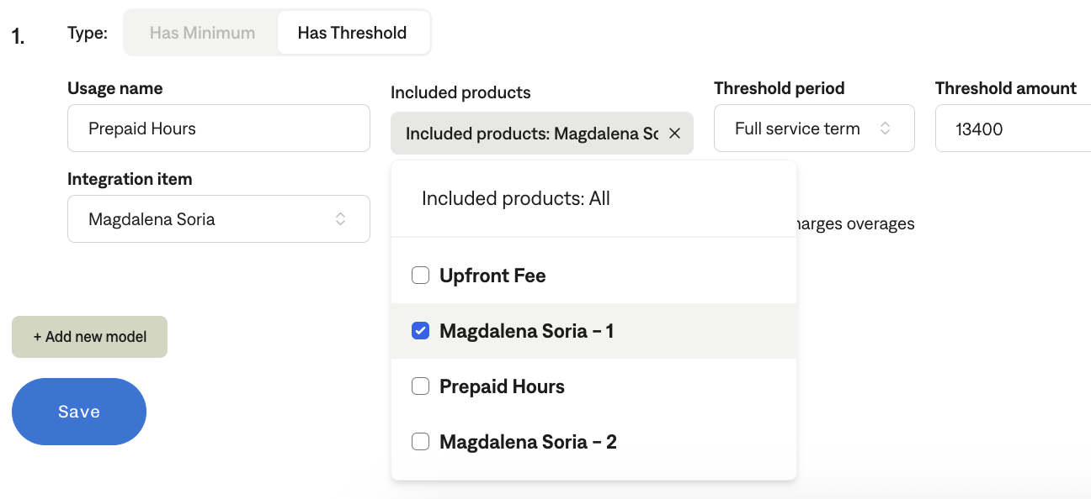

1. Threshold period = **Full service term** (default setting)
2. Charges overage = **Toggle ON** (default setting)
3. Adjustment name = **Prepaid hours**
4. Integration item = **same integration item used in the BT** (Name of legal professional)
5. Amount = **hourly rate from contract * # of hours allocated**. This will be the same amount as the Upfront Fee amount
6. Service period = Check on **Service period same as contract** (default setting)

**Sometimes for up-front contracts, if all of the hours are used up, the customer will add more, which is done via email. To process this:**

1. Go to the original customer (The customer can be identified by their email address)
2. Add new upfront payment BT (same requirements as above)
3. If the original usage RS/BT is over or has less than 6 months left, extend another year (unless a different time frame is specified in the email)
   1. If the rate also changes per the email, update the price on the BT as well
4. In the Usage AI, update the threshold to the new upfront payment amount

Example of an email thread for this:

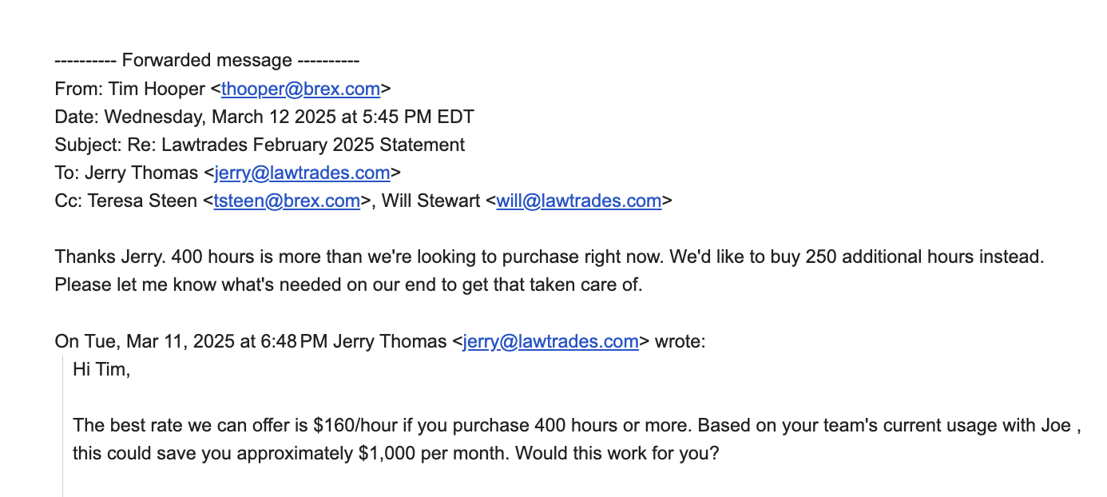

[**Original Enablement Meeting Recording**](https://www.loom.com/share/173f81cb33cb4bd88aac6719653798e9?_hsenc=p2ANqtz-9gpMsiz1xC2-ERxIpJdJd1LeQmBg_8hJczADoqwILECJ5JR3qaL7HrUFqsY_J8Nwz8Zl2hTWFl6HHxAdFBcJrzLbHptA&_hsmi=325882948&utm_content=325882948&utm_medium=email&utm_source=hs_email)

1. Anything to ignore in contracts?
2. Default Service Term
   1. If None Listed, Ops Default is 1 Year
3. Default Net Payment Terms
   1. Default 30
4. Default Billing Frequency
   1. If None Listed, Ops Default is Monthly
5. How do we handle taxes as a line item?
   1. If None Listed, Ops Default is every tax line item becomes a BT

### Events Processing (if necessary) *(Implementation/Success to fill)*

* Detailed above in processing instructions

Integration Items Processing (if necessary)  
*(Implementation/Success to fill)*

* Detailed above in processing instructions

Post Processing Communications (if necessary)  
*(Implementation/Success to fill)*

* Does the Ops Team need to notify anyone on the team re: completion of processing batches in Implementation or Active phase?
* Who needs to be notified and when?
  + Example:
    - Who: Customer Success [Azmat Aziz] needs to be notified
    - Where: Messari internal merchant channel
    - When: contracts are processed [Merchant Phase: Active]

### Customer Information *(Implementation/Success to fill)*

* Any important information on specifics customers of this merchant
  + Special memo’s certain invoices require
  + Invoice changes due to merchant/customer relationship

### Feature Requests *(AE/Implementation/Success to fill)*

* OatFi Integration
  + They factor their invoices through OatFi to get cash upfront then payout Oatfi with interest when invoices are paid
  + Need Cash upfront - they have very bad DSO of ~60 days
  + Timeline is March. Deepak and GS gave the thumbs up after meeting with OatFi team pre MSA
* Professional Services
  + They want Tabs to run all of their billing rather than hiring a billing manager
  + GS owning this by devoting resources to acting as a AR clerk
  + Potential upsell in March

### Rewatch Calls *(AE/Implementation/Success to fill)*

* 6/13/24 - First Intro Call
  + https://tabs.rewatch.com/video/ga7411e2p5ap0ybo-jerry-nicholas-meeting-june-13-2024
* 6/26/24 - Custom Demo with Jerry
  + https://tabs.rewatch.com/video/2ss3x5h36acypq8u-jerry-thomas-and-nicholas-gatti-june-26-2024